CONFERENCE REGISTRATION PORTAL
@CREATIVITY THINK (9483175986/7019689991)

ABSTRACT:
Conference Registration Portal is a web application that facilitates efficient management of conferences, seminars, and business events. Users can browse events, register or RSVP, pay fees, and access a dashboard displaying their event participation and schedule. Administrators can add events and speakers, manage attendees, view payment reports, and monitor analytics. Built with Django and Django Rest Framework for backend operations, and React, recharts, and pdfkit for frontend and reporting, this system centralizes conference registration, automates payment tracking, and provides comprehensive analytical insights for both users and event organizers..

INTRODUCTION OF THE PROJECT:
Managing conference registrations manually can lead to errors, missed attendees, and inefficient payment tracking. Conference Registration Portal addresses these challenges by offering a centralized platform for users to register, pay, and access event details. Administrators can manage events and speakers, monitor attendees, and generate reports for analysis. The backend handles authentication, registration logic, and payment tracking, while the frontend provides interactive dashboards and PDF report generation. This system streamlines event organization, improves user experience, and enhances administrative oversight through analytical dashboards..

PROJECT OBJECTIVES:

• Allow users to browse and register for events efficiently
• Provide secure fee payment processing
• Display event schedules and attendee dashboards
• Enable administrators to add events and speakers
• Manage attendee lists and payment tracking
• Generate dashboard analytics for user participation and financial reporting
• Automate PDF generation for registration and event reports
• Ensure secure and reliable data management for users and administrators

PROBLEM OF THE STATEMENT:
Manual conference registration often results in administrative inefficiencies, errors in attendee tracking, delayed payments, and lack of analytical insight. Organizers struggle to manage event logistics, while attendees face difficulties in registration and schedule access. Conference Registration Portal addresses these challenges by centralizing event registration, automating payment processing, providing dashboards for both users and administrators, and generating PDF reports for comprehensive event management. This reduces errors, improves participant experience, and provides actionable analytics for organizers..

MOTIVATION OF THE PROJECT:
• Simplify conference and seminar registration processes
• Automate fee payment and receipt generation
• Provide easy access to event schedules and speaker information
• Centralize attendee management and reporting
• Offer analytics dashboards for event performance monitoring

BLOCK DAIGRAM OF PROJECT:

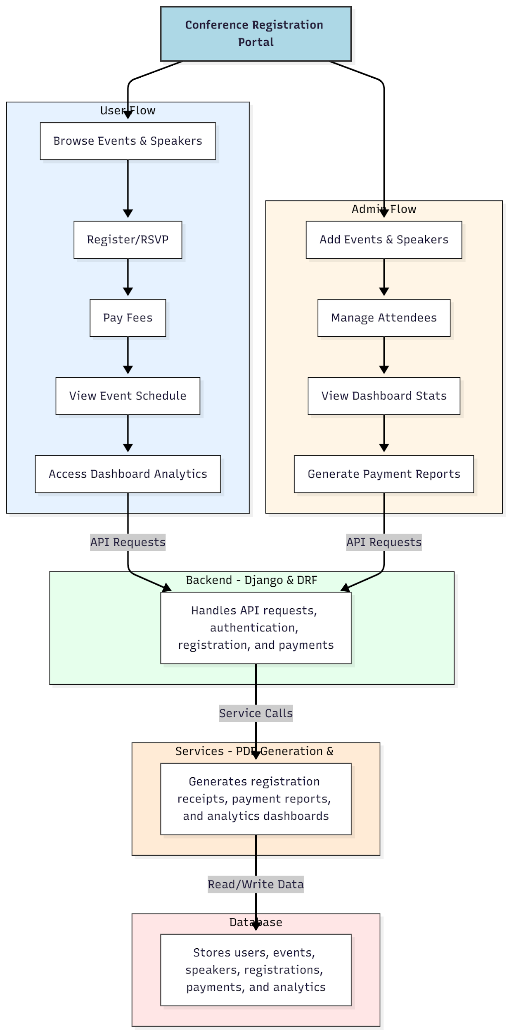

WORKING OF THE PROJECT:
Users browse events and speaker information, register or RSVP for events, make payments, view schedules, and access analytical dashboards. Administrators add events and speakers, manage attendee lists, monitor dashboard statistics, and generate payment reports in PDF format. The backend handles authentication, registration logic, and payment processing, while services generate PDFs and compute analytics. The database stores users, events, speakers, registrations, payments, and analytical data. This system streamlines conference registration, improves payment accuracy, and provides insights for better event management..

SOFTWARE REQUIREMENT:
- Backend:
  - Python 3.x
  - Django
  - Django REST Framework
  - SQLite/PostgreSQL
- Frontend:
  - Node.js and npm
  - React.js
  - Axios
- Development Tools:
  - Visual Studio Code
  - Postman (for testing APIs)
  - Git/GitHub (for version control)
- Server/Deployment (Optional):
  - Gunicorn, Nginx, or Heroku/AWS for hosting

ADVANTAGES OF THE PROJECT:

• Centralizes conference and seminar registrations
• Automates fee payment and receipt generation
• Provides event schedules and speaker information
• Manages attendee lists efficiently
• Generates PDF reports for payments and registrations
• Displays dashboard analytics for users and administrators
• Reduces administrative errors and delays
• Enhances event management efficiency and participant experience

APPLICATIONS OF THE PROJECT:
• Conference and seminar registration portals
• Business event management platforms
• Workshops and training program registrations
• Academic symposiums and summits
• Online payment and receipt tracking for events
• Event analytics and performance dashboards
• PDF generation for registrations and payment reports
• Centralized attendee and speaker management

REFERENCES:

- Django REST Framework Documentation — Django Software Foundation. Django Documentation. Available: https://docs.djangoproject.com/
- Django REST Framework. DRF Documentation. Available: https://www.django-rest-framework.org/
- React. React Official Documentation. Available: https://reactjs.org/docs/getting-started.html
- Redux. Redux Documentation. Available: https://redux.js.org/introduction/getting-started
- PostgreSQL Global Development Group. PostgreSQL Documentation. Available: https://www.postgresql.org/docs/
- MySQL. MySQL Reference Manual. Available: https://dev.mysql.com/doc/
- Git. Git Documentation. Available: https://git-scm.com/doc
- Node.js. Node.js Documentation. Available: https://nodejs.org/en/docs/
- Axios. Axios Documentation. Available: https://axios-http.com/docs/intro
- Socket.io Documentation – https://socket.io/docs/

